1- Look and write
path park grass flowers garbage can trees fountain litter

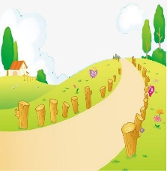 | 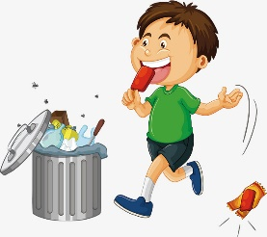 | 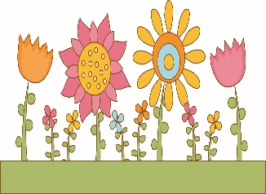 | 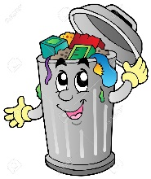
path | litter | flowers | Garbage can
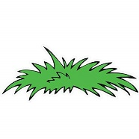 | 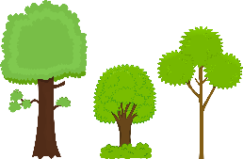 |  | 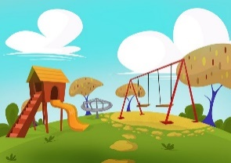
grass | trees | fountain | park
2-Look at the signs and complete the sentences with must or mustn’t .
1.You __mustn’t____ ride your bike on the grass.
2. You __must __ walk on the paths.
3. You __must____use the garbage can.
4. You ___mustn’t_______ light fires.
5. You ___mustn’t____ take photos.
3.Read and number
1.f 2. J 3.d 4.e 5.i 6.a 7.h 8.b 9.g 10.c
4.Look ,choose and write with must or mustn’t .
He mustn’t run. She must wear a helmet. She must eat her salad.
She must go to the dentist. He mustn’t take photo. She mustn’t drive fast.

5.Read and correct the mistak
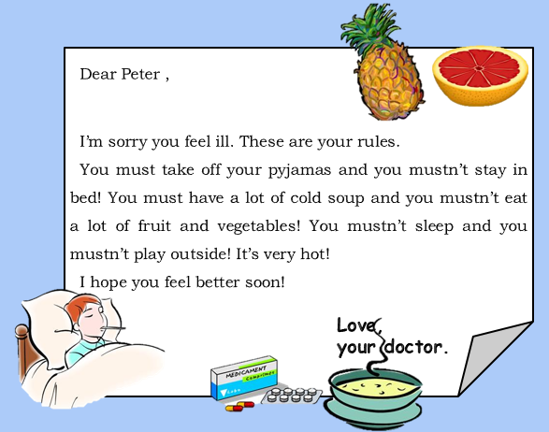

___must__
___must_
___must_____
________
________
________

6.Read and write
- On Monday Dad must cook dinner.
- On Tuesday Maddie must make sandwiches for the school picnic.
- On Wednesday Mum and Dad must go to the supermarket.
- On Thursday Brad and Maddie must study for geography test.
- On Friday Brad must wash Buster
- On Friday Mum and Dad must buy a new sofa.
- On Saturday Brad , Maddie , Mum and Dad must clean the house.

